Lab 2 - Implementing Decision Instructions in RISC V Assembly Language

Name: Romaisa Shazad  Myrah Hussain | Student ID: rb10107  mh10074

Task 1:

(for my help)
- Copy Code (remove the non assembly part)
- Ctrl shft d gives me run and debug - values stored in register
- Ctrl shft p -> venus assembly -> left column Program counter -> middle column is the hex value of the instruction. Alt we can also do ctrl shaft d -> venus options -> assembly
- Open calculator on laptop -> programmer options -> hex -> copy the hex value -> convert to binary -> copy the binary value somewhere
- Open the RISC V data green card -> code instruction format -> SB and then arrange bits according to each heading -> for unsigned extend MSB to make 32 bit
- We will have 2 imm values -> sort them
- left shift by 1 -> that’s the answer

Code:
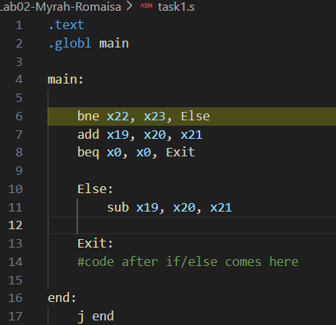

Results:

Listing 3:
Instruction: bne
Hex: 0x017B1663
Binary: 0000 0001 0111 1011 0001 0110 0110 0011

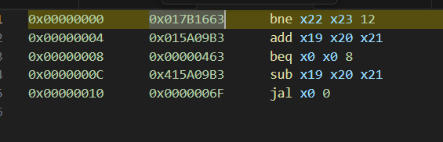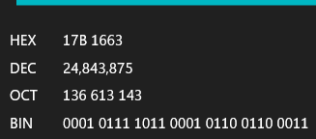

Field Extraction:

0110 0011 → op code

01100 imm [4:1[11]]

0000 000 imm[12 10:5]

0000 0000 0110 << 1 = 0000 0000 1100 (left shift 1 bit)

For BEQ:
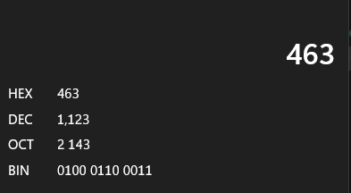
0000 0000 0000 0000 0000 0100 0110 0011 → Binary

110 0011 → OP code

01000 → imm [4:1 | 11]

0000 000 imm[12 | 10:5]

0000 0000 0110 << 1 = 0000 0000 1100 (left shift 1 bit)

Task 2:

Code:
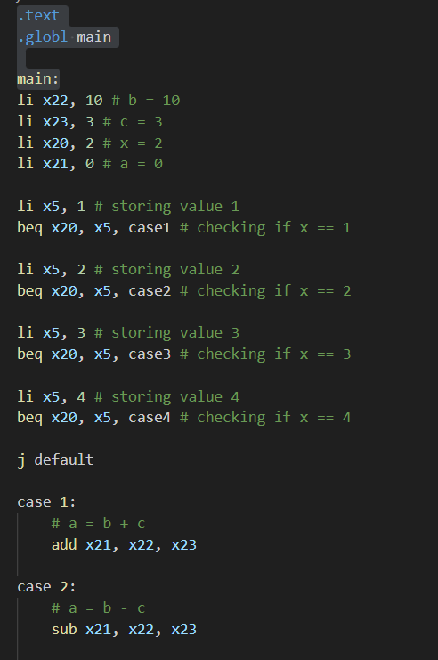
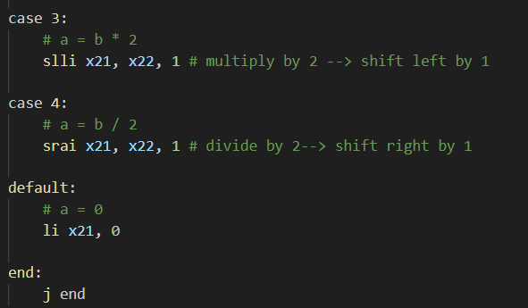

Results:
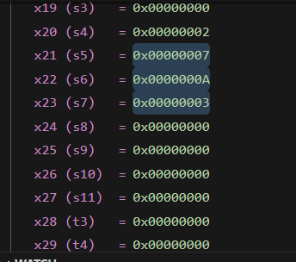

Task 3:

Code:
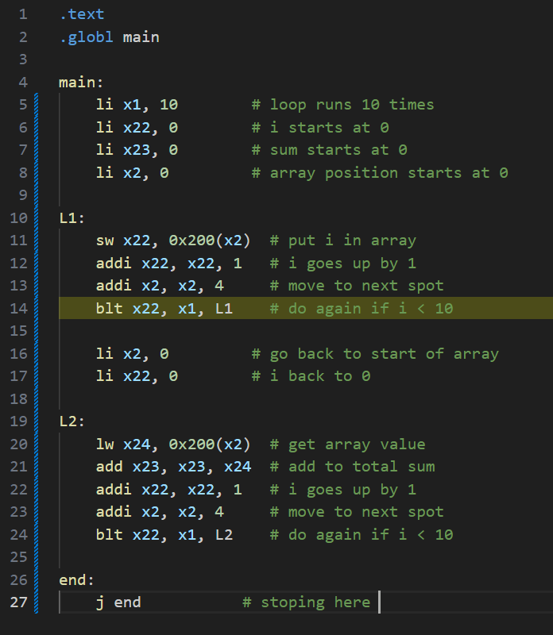

Results:

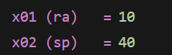
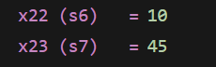

Address:
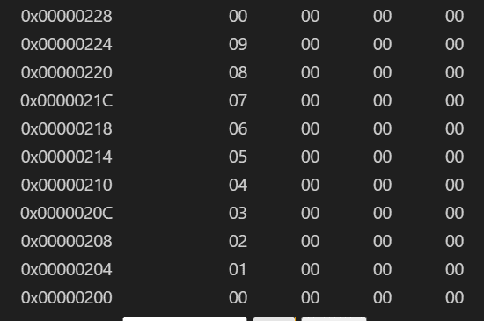

Task 4:

Code:

Results:

Assessment Rubric
Lab 2 - Implementing Decision Instructions in RISC V Assembly Language

Name | Student ID: | Section:

Points Distribution:

 | Task No. | LR 2 (Code) | LR 5 (Results)
In-Lab | Task 1 | - | /5
In-Lab | Task 2 | /10 | /10
In-Lab | Task 3 | /15 | /10
In-Lab | Task 4 | /20 | /10
Total Points: 100 |  | /45 | /35
CLO Mapped |  | CLO 2

Affective Domain Rubric |  | Points | CLO Mapped
AR7 | Report Submission & Git Upload | /10 & /10 | CLO 2

CLO | Total Points | Points Obtained
2 | 100
Total | 100

